**Question 1:**

**What are the Levels of Program Code and the two components that translate the program higher levels to lower levels?**



**Question 2:**

**We have two computers; where Computer A has Cycle Time = 400ps and CPI=1.2; and Computer B has Cycle Time=200ps and CPI=2.0, and both have same ISA.**

**Assume that both computers (A & B) ran the same software program with the exact instruction sequences, i.e. the same number of instructions.**

1. **Which one is faster?**



1. **By how much?**

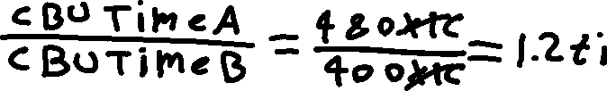

**Question 3**: Alternative compiled code sequences using instructions in classes A, B and C as listed in the below table.

|  |  |  |  |
| --- | --- | --- | --- |
| Class | A | B | C |
| Cycles Per Instruction (CPI) for class | 3 | 2 | 1 |
| Instruction Count in sequence 1 | 2 | 1 | 2 |
| Instruction Count in sequence 2 | 4 | 1 | 1 |

1. What is the number of instructions in **sequence 1**?



1. What is the number of instructions in **sequence 2**?



1. What is the number of clock cycles required to complete all instructions in **sequence 1**?



1. What is the number of clock cycles required to complete all instructions in **sequence 2**?



1. What is the Weighted average CPI (Average CPI) in **sequence 1**?



1. What is the Weighted average CPI (Average CPI) in **sequence 2**?

